Image and Tag
- Any docker image represents some application. Every application will have multiple versions.
- In Docker to represent application we use name of image and to represent version we use tag. The convention <image-name>:<tag>
hello-world => hello-world:latest
- If the tag is not passed docker assumes the tag to be latest
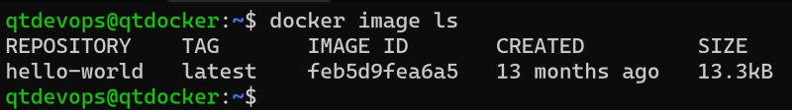
- Along with Repository (image name) and tag we also have image-id
